**Abstract:**

A gesture Controlled bot, as the name suggests, is a non-autonomous bot controlled by hand gestures that is communicated to it via signals sent by accelerometer. The movement of the accelerometer provides certain coordinates that are processed by our microcontroller (Arduino UNO) and then provided to the bot as input. The bot then provides the output depending upon the threshold set by the user while programming it. The basic components to build this project are L293D board, Arduino UNO, ADXL335 accelerometer along with some batteries and connection wires. The accelerometer is an essential device in this project. Here a gesture device works as a transmitter and a robot works as a receiver. Our bot uses four DC motors for its movements. Suppose when the user wants to bend the bot towards the right hand side, the front wheel of the right side and the back wheel of the left side will seize to function and the front left wheel along with the right-back wheel will move thereby turning it in the required direction.

**Circuit Diagram:**

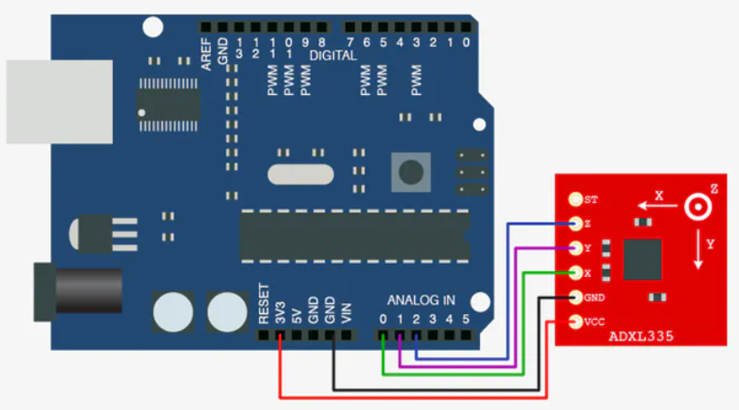

Arduino UNO to ADXL335 Connections

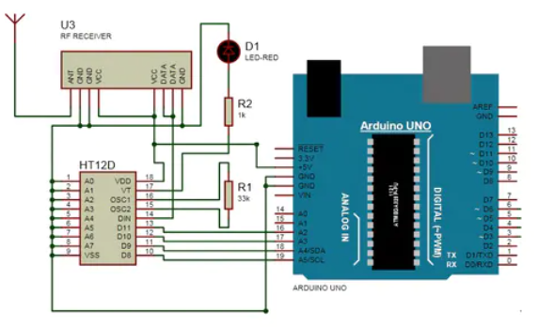

Complete Circuit

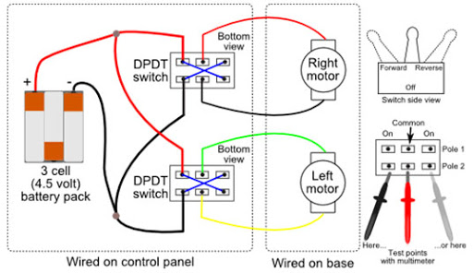

Motor Connections

(Source: www.robotiod.com)

**Test Cases:**

|  |  |  |  |  |  |
| --- | --- | --- | --- | --- | --- |
| Movement of hands(INPUT) | Right Front Wheel | Left Front Wheel | Right Back Wheel | Left Back Wheel | Direction  (OUTPUT) |
| 1.No Movement | 0 | 0 | 0 | 0 | Stable |
| 2.Forward | +1 | +1 | +1 | +1 | Moves Forward |
| 3.Backward | -1 | -1 | -1 | -1 | Moves Backward |
| 4.Right | 0 | +1 | +1 | 0 | Moves Right |
| 5.Left | +1 | 0 | 0 | +1 | Moves Left |

Here in the table:

0 - Stable/ Stop Position

+1 - Move Forward/Positive Rotation Position

-1 - Move Backward/Negative Rotation Position